Big Mountain Resort Profit Recovery

Dylan Neal

Springboard Data Science Career Track

March 30th Cohort

# Background

Big Mountain Resort has recently installed an additional chair lift to help increase distribution of visitors across the mountain. The chair increases operating costs by $1.54 M. The current profit margin is 9.2%, and investors would like to keep it there.

# Approach

A dataset was provided containing information on 330 ski resorts across North America. The metadata is summarized in figure 1.

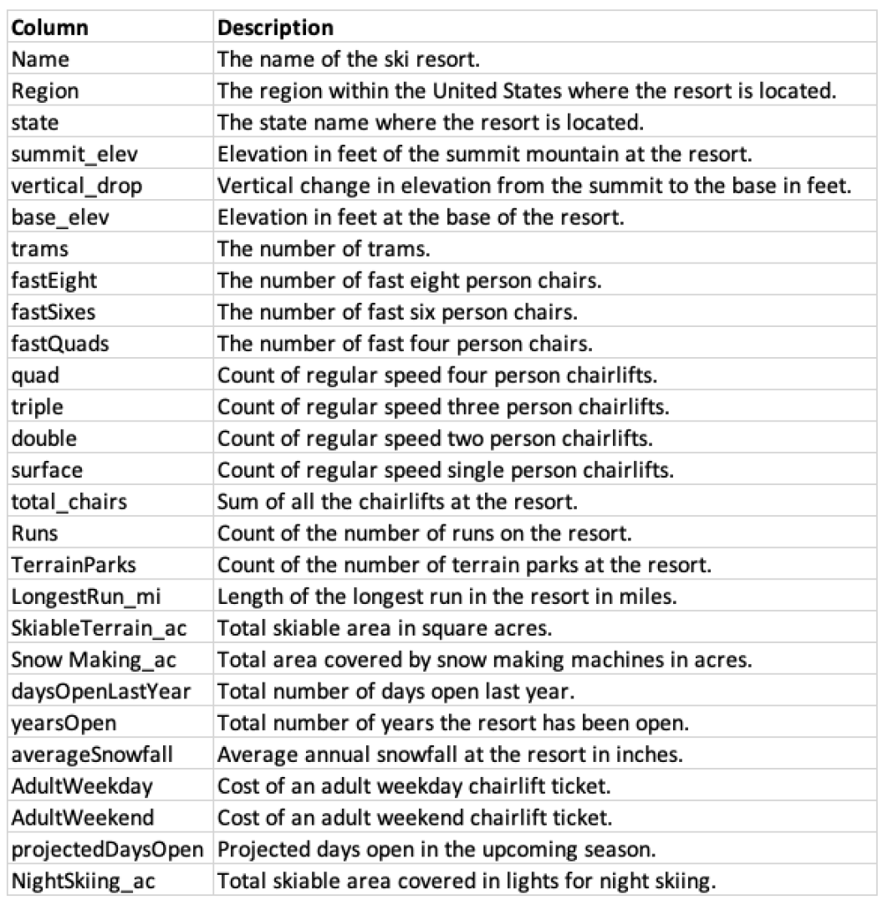

*Figure 1. Dataset metadata*

The goal was to determine if profits could be maintained at 9.2% by reasonably adjusting adult weekend price. To do this, a model would be built to predict what the price of an adult weekend ticket should be at Big Mountain Resort given its features compared to other ski resorts across North America.

The dataset was scrubbed prior to model training. Null values were filled, outliers removed, duplicate rows dropped, and redundant features removed. An additional feature was added to the dataset via k-means clustering to categorize the ski resorts into 3 separate related bins.

# Execution

A regression model was implemented, attempting several modified iterations. The final model that was executed dropped the ‘state’ feature from the data set. The explained variance score and mean absolute error from testing this model are displayed in table 1.

| **Explained Variance** | **Mean Absolute Error** | **Features Dropped** |
| --- | --- | --- |
| 0.9141 | 5.5046 | 'state' |

*Table 1. model performance metrics*

# Results

The model was executed and the appropriate adult weekend ticket price for Big Mountain Resort was predicted to be $93.20. The current price is $81.00. Assuming minimal drop in weekend attendance, this would represent an approximate 15% increase in revenue from adult weekend tickets. This could protect the current profit margin at 9.2%, and potentially increase it.